Generate config file:
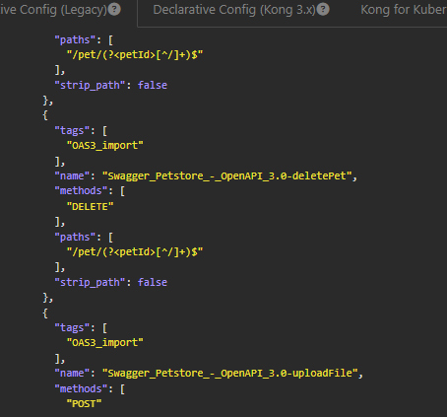

This file you need to save it as .yaml file in ur deck folder.
Then use deck ping
After that deck sync
So this file will get updated in kong manager so all services will be created in kong manager.
You need to use

Your deck is inside deck file hence inside kong-entererprise go inside deck file.

Keeep the base address as localhost in open api.

